AP Physics Sound Multiple Choice Practice

- A string is firmly attached at both ends. When a frequency of 60 Hz is applied, the string vibrates in the standing wave pattern shown. Assume the tension in the string and its mass per unit length do not change. Which of the following frequencies could NOT also produce a standing wave pattern in the string?

A) 30 Hz B) 40 Hz C) 80 Hz D) 180 Hz

2. If the speed of sound in air is 340 m/s, the length of the organ pipe, open at both ends, that can resonate at the fundamental frequency of 136 Hz, would be:
A) 0.40 m B) 0.80 m C) 1.25 m D) 2.5 m

3. A pipe that is closed at one end and open at the other resonates at a fundamental frequency of 240 Hz. The next lowest/highest frequency it resonates at is most nearly.
A) 80 Hz B) 120 Hz C) 480 Hz D) 720 Hz

4. Assume the speed of sound is 340 m/s. One stereo loudspeaker produces a sound with a wavelength of 0.68 meters while the other speaker produces sound with a wavelength of 0.65 m. What would be the resulting beat frequency?
A) 3 Hz B) 23 Hz C) 511.5 Hz D) 11,333 Hz

5. A tube of length L₁ is open at both ends. A second tube of length L₂ is closed at one end and open at the other end. This second tube resonates at the same fundamental frequency as the first tube. What is the value of L₂ ?

A) 4L₁ B) 2L₁ C) L₁ D) ½ L₁

Questions 6-7
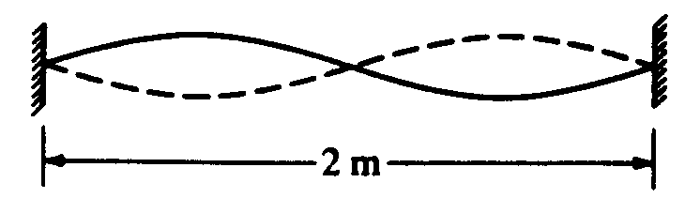
A standing wave of frequency 5 hertz is set up on a string 2 meters long with nodes at both ends and in the center, as shown above.

6. The speed at which waves propagate on the string is
A) 0.4 m/s B) 2.5 m/s C) 5 m/s D) 10 m/s

7. The fundamental frequency of vibration of the string is
A) 1 Hz B) 2.5 Hz C) 5 Hz D) 10 Hz

8. Multiple correct: In the Doppler Effect for sound waves, factors that affect the frequency that the observer hears include which of the following? Select two answers.

A) the loudness of the sound
B) the speed of the source
C) the speed of the observer
D) the beats of the sound

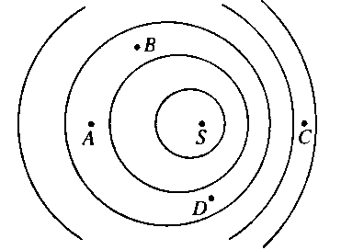

9. A small vibrating object on the surface of a ripple tank is the source of waves of frequency 20 Hz and speed 60 cm/s. If the source S is moving to the right, as shown, with speed 20 cm/s, at which of the labeled points will the frequency measured by a stationary observer be greatest?

(A) A (B) B (C) C (D) D

10. The frequencies of the first two overtones (second and third harmonics) of a vibrating string are f and 3f/2 .What is the fundamental frequency of this string?

A) f/3 B) f/2 C) f D) 2f

11. Multiple Correct: Two fire trucks have sirens that emit waves of the same frequency. As the fire trucks approach a person, the person hears a higher frequency from truck X than from truck Y. Which of the following statements about truck X can be correctly inferred from this information? Select two answers.

A) It is traveling faster than truck Y.
B) It is closer to the person than truck Y.
C) It is speeding up, and truck Y is slowing down.
D) Its wave fronts are closer together than truck Y.

